Name: Mriganka Patra

Email – [mriganka.patra@cognizant.com](mailto:mriganka.patra@cognizant.com)

Emp id - 2415820

Assignment 2: Object Manager, App Builder, and Page Customization

Objective:

Learn to navigate Salesforce CRM by working with Object Manager, Customizing apps and interfaces using the Lighting APP Builder:

Tasks:

1. Log into a Salesforce Developer Account
2. Navigate to Object Manager and Create Custom Object named ‘ Project’
3. Add at least 5 custom fields (Ex: Project Name, Start Date, End Date, Status, Budget)
4. Create a new tab for the ‘Project’ Object
5. Customize the page layout to show only relevant fields and record sessions.
6. Use Lighting App Builder to create a new app including the ‘project” object and assign it to a profile
7. Create two different Record Types for ‘Project’: Internal and Client-based projects with different layouts

Deliverables:

* Screenshots or steps for creating custom object, tab and layouts
* Summary of record types and configuration

Task 1: Log into a Salesforce Developer Account

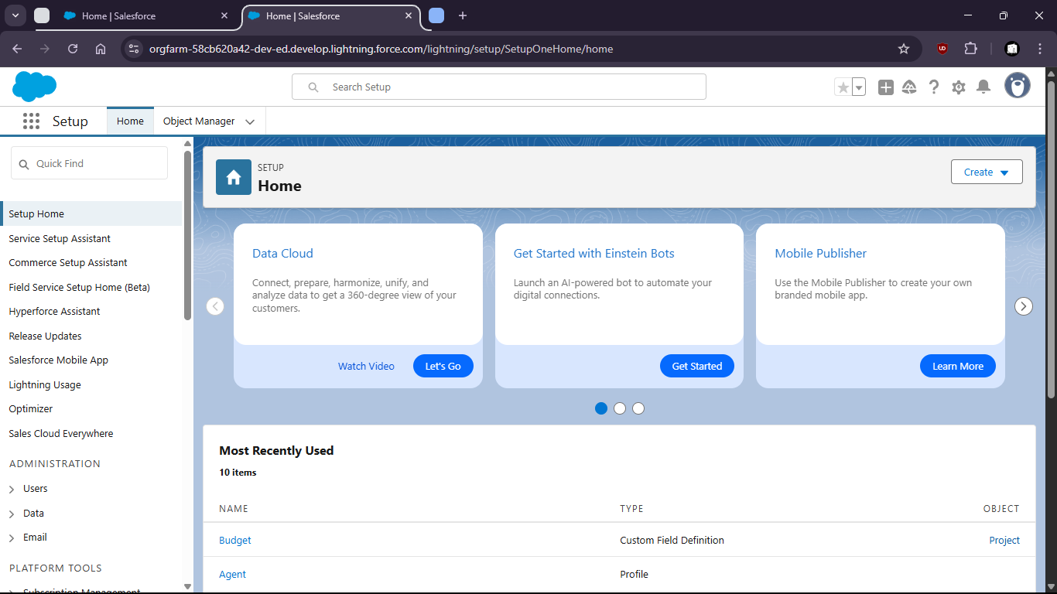

Task 2 : Navigate to Object Manager and Create Custom Object named ‘ Project’

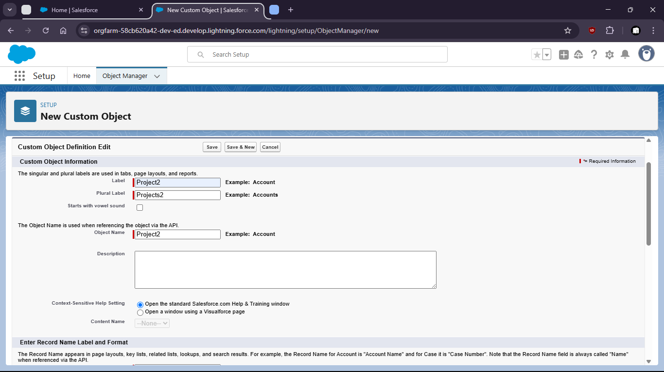

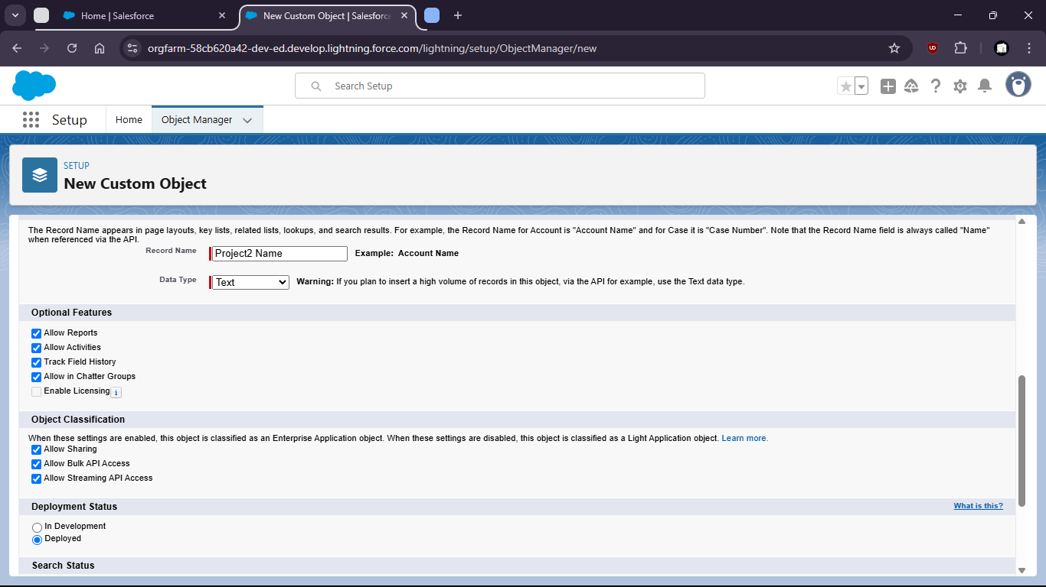

Task 4 : Create a new tab for the ‘Project’ Object

Go to tabs and set visibility, etc

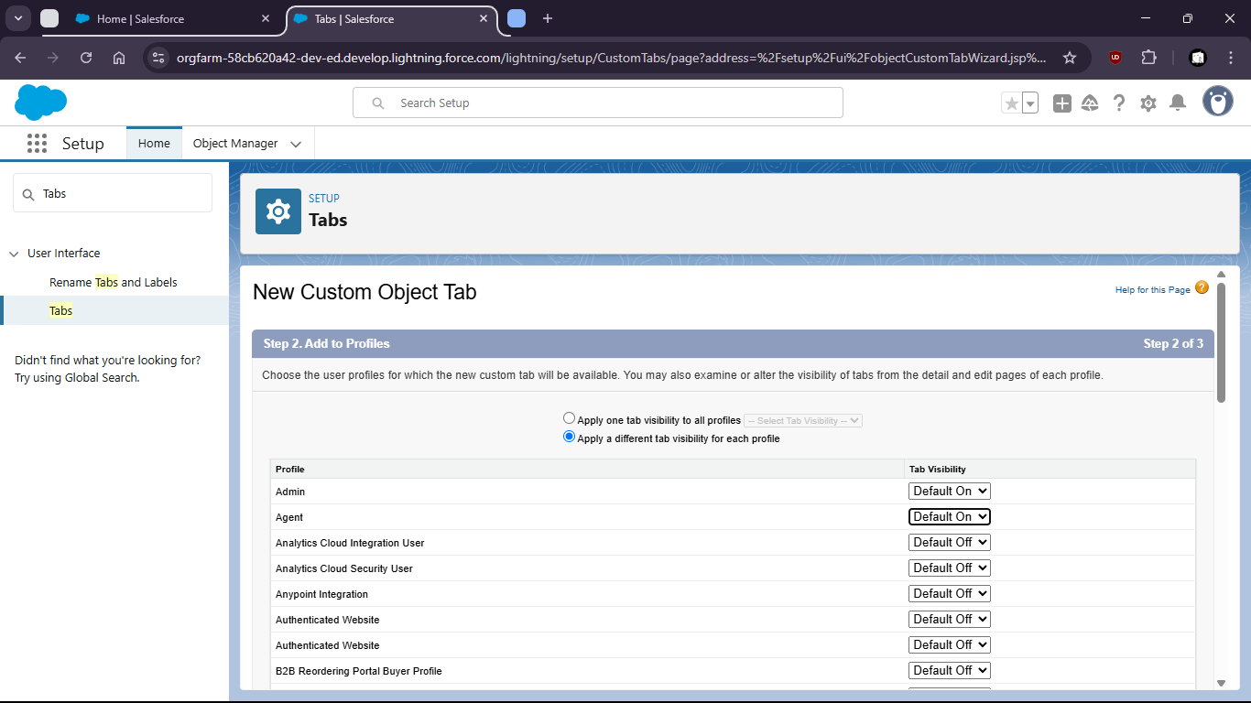

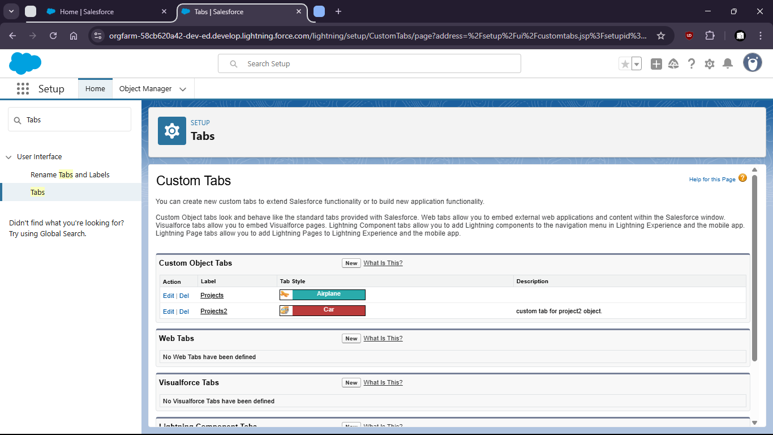

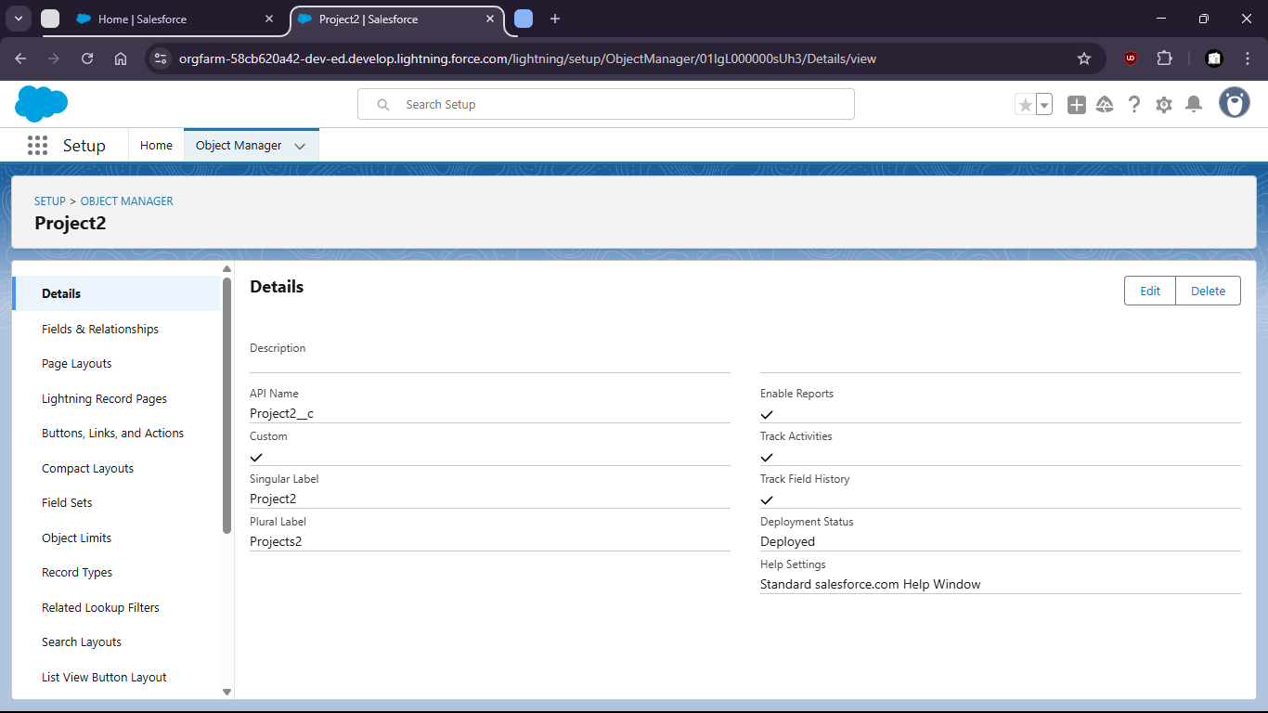

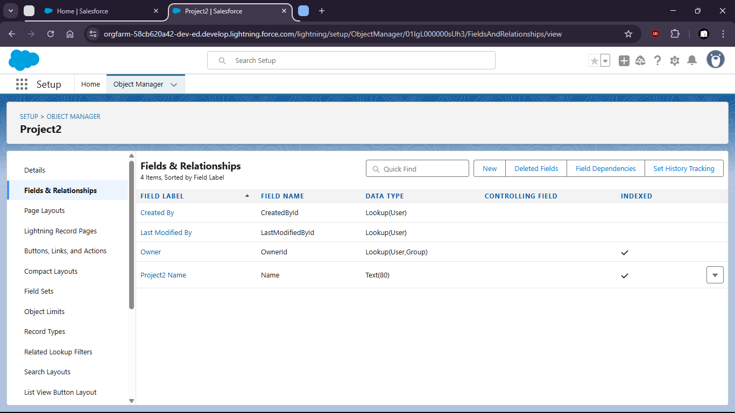

Task 3 : Add at least 5 custom fields (Ex: Project Name, Start Date, End Date, Status, Budget)

- Start date addition.

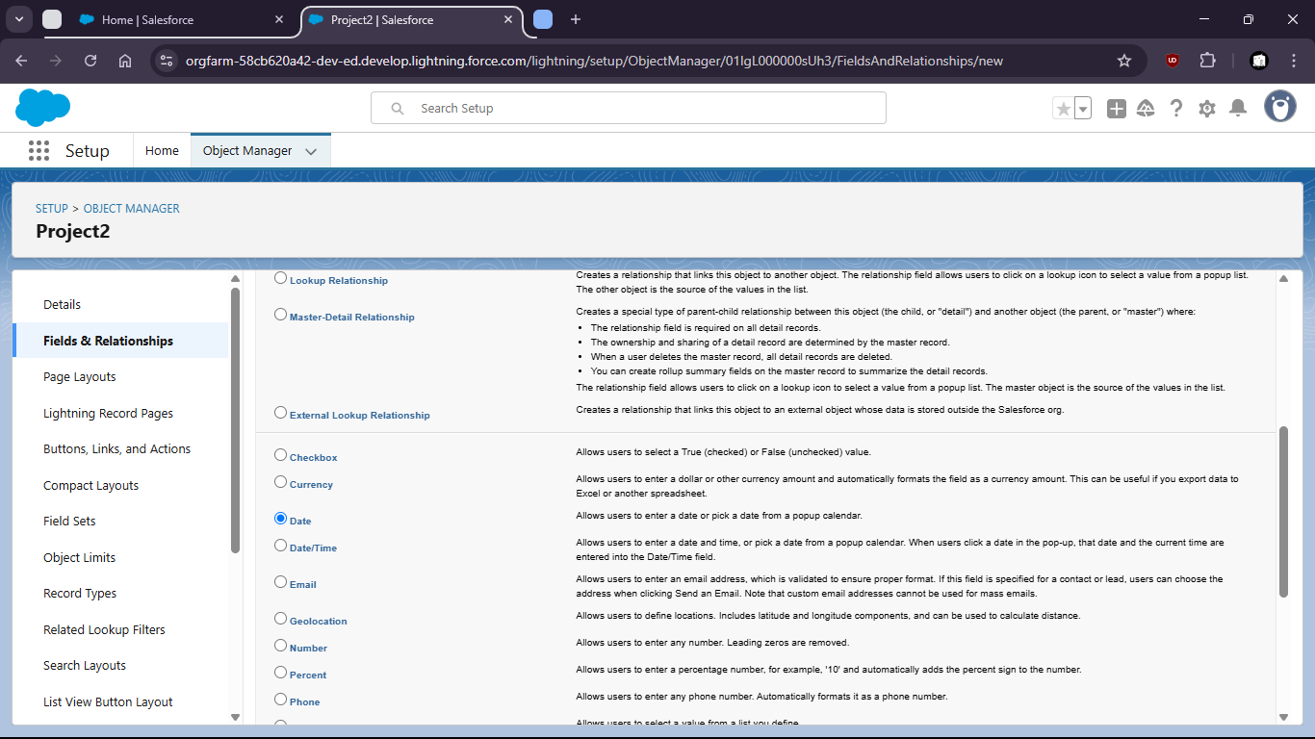

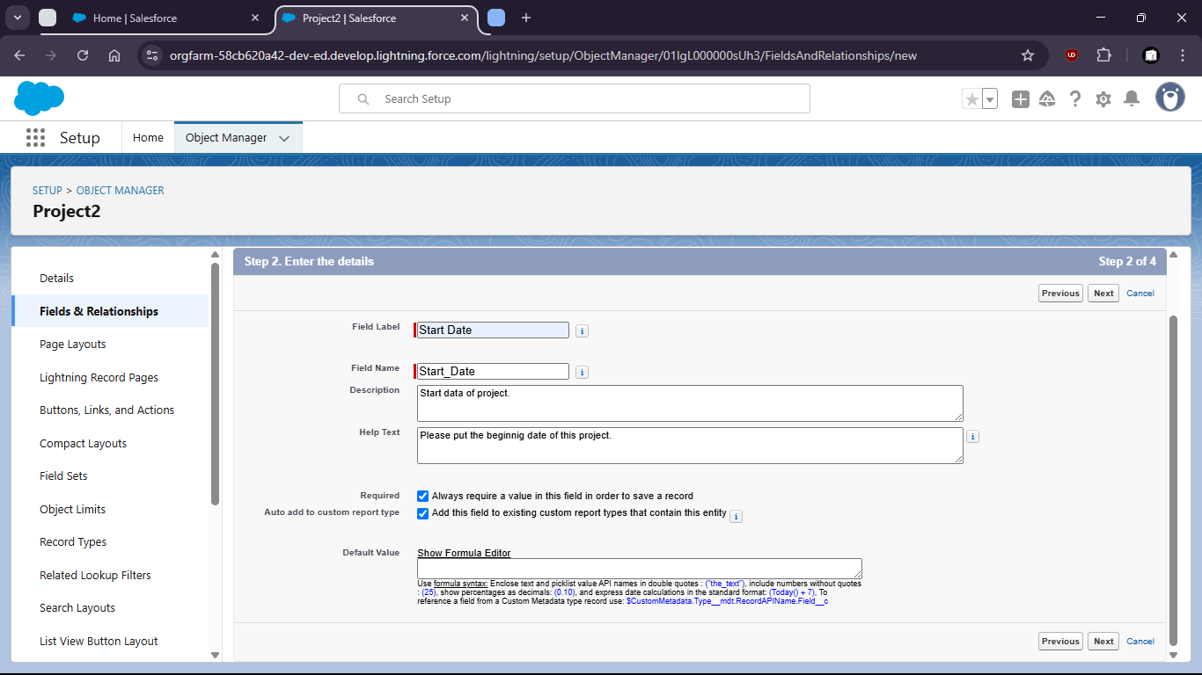

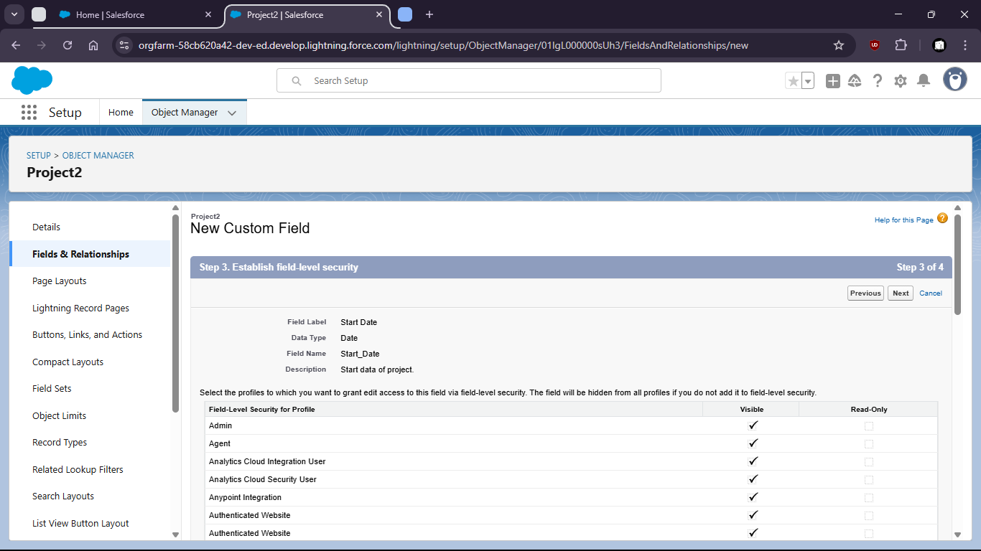

- Pick-list addition

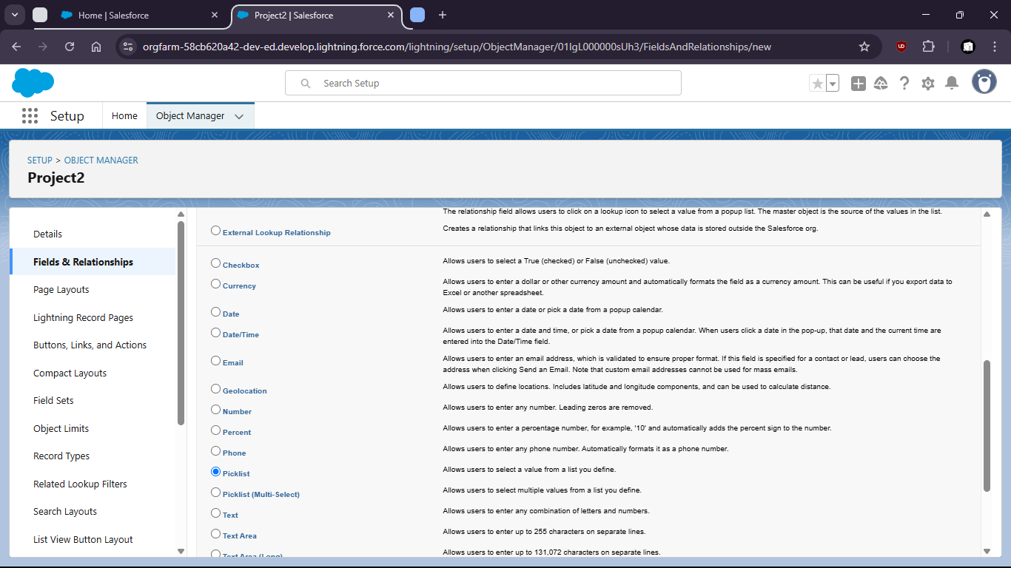

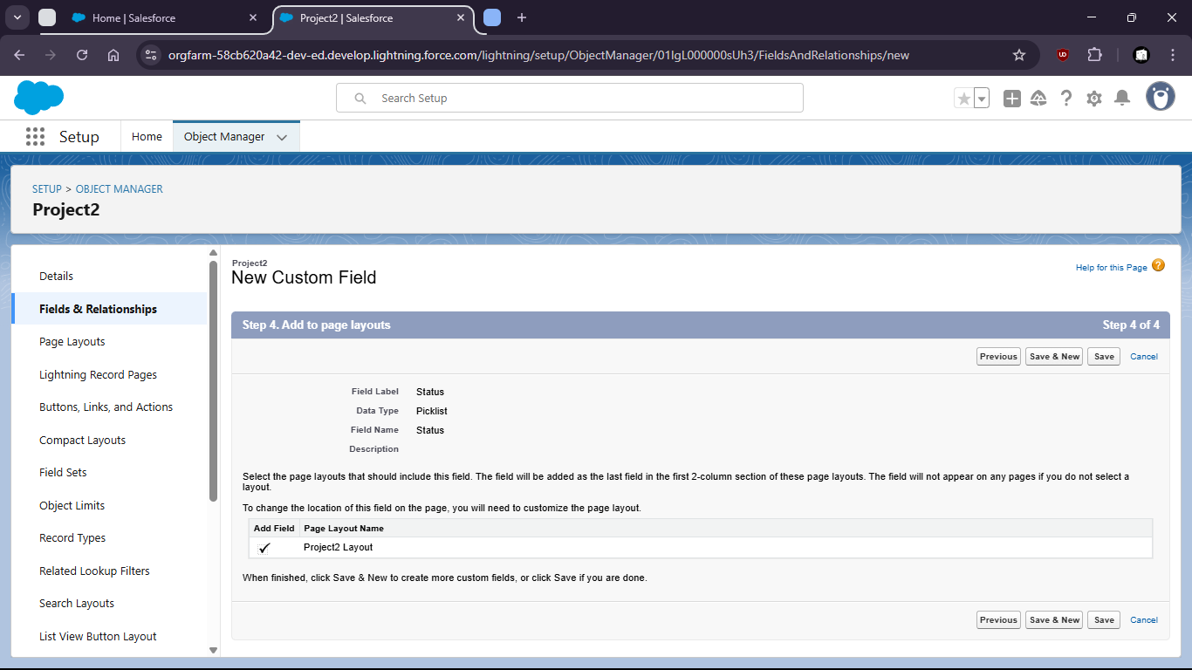

For Budget pick ‘Currency’

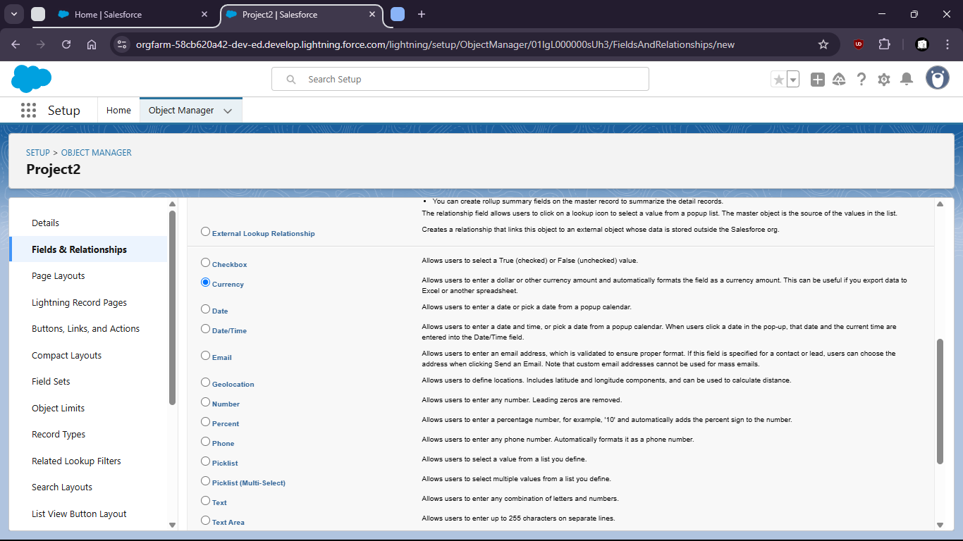

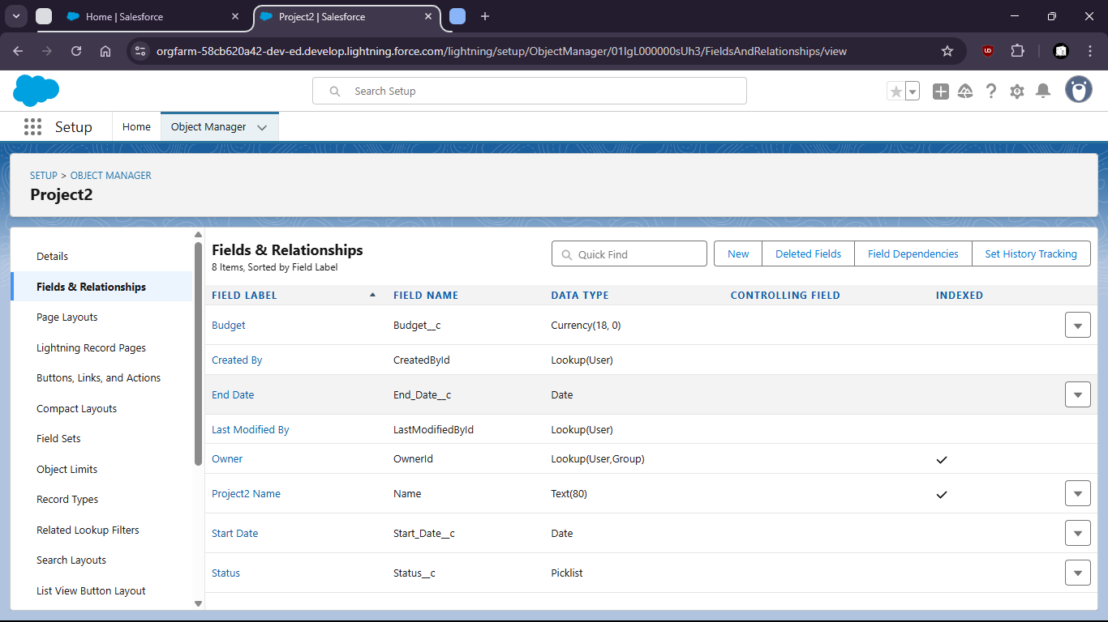

Task 5 : Customize the page layout to show only relevant fields and record sessions.

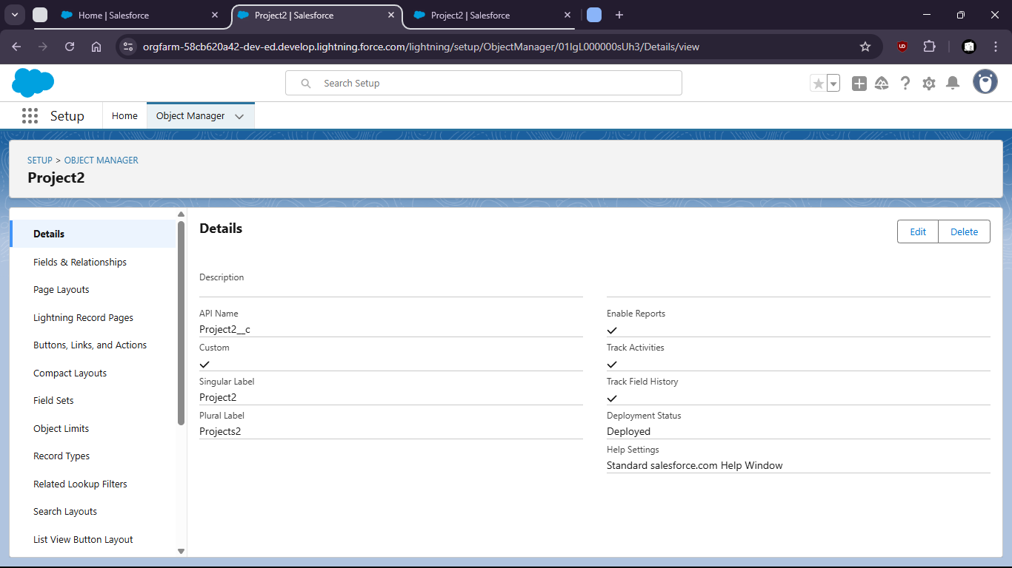

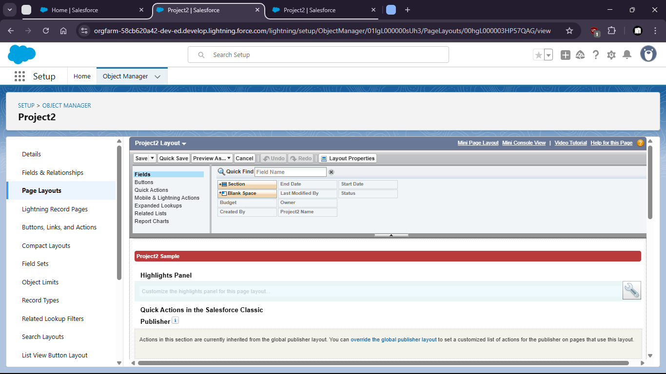

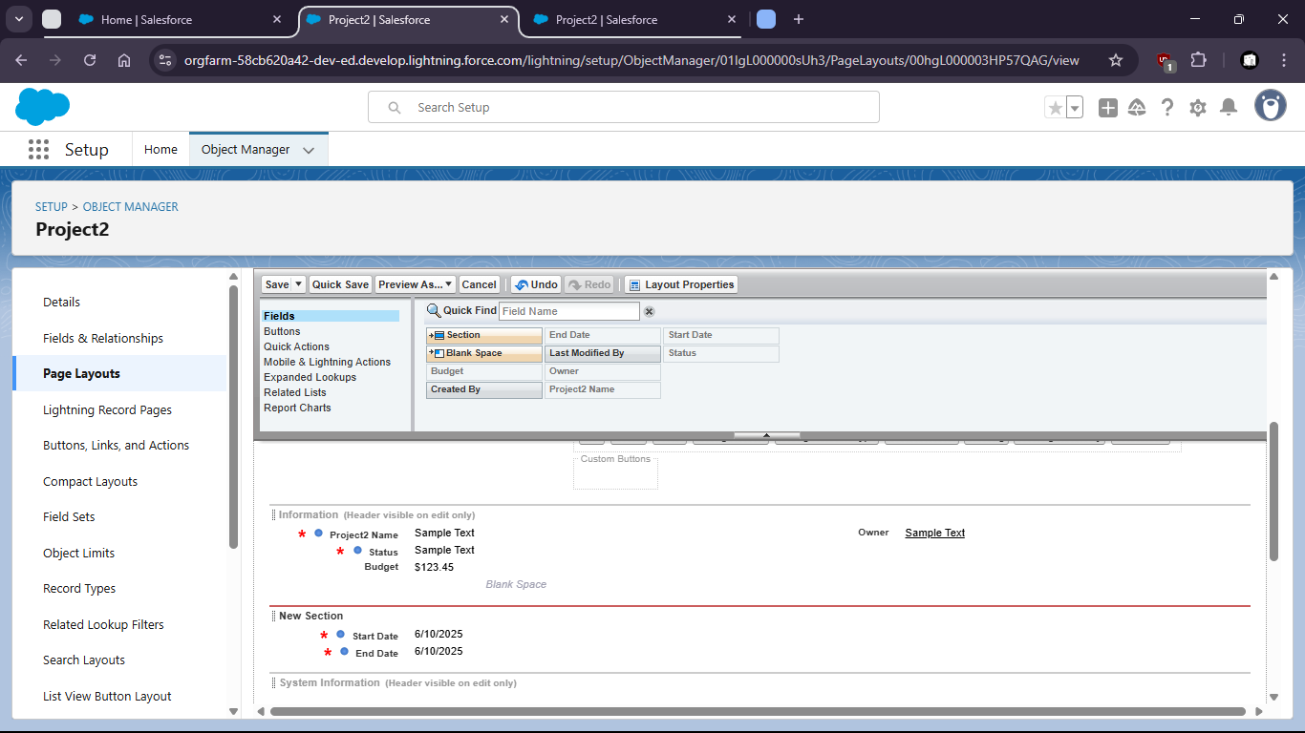

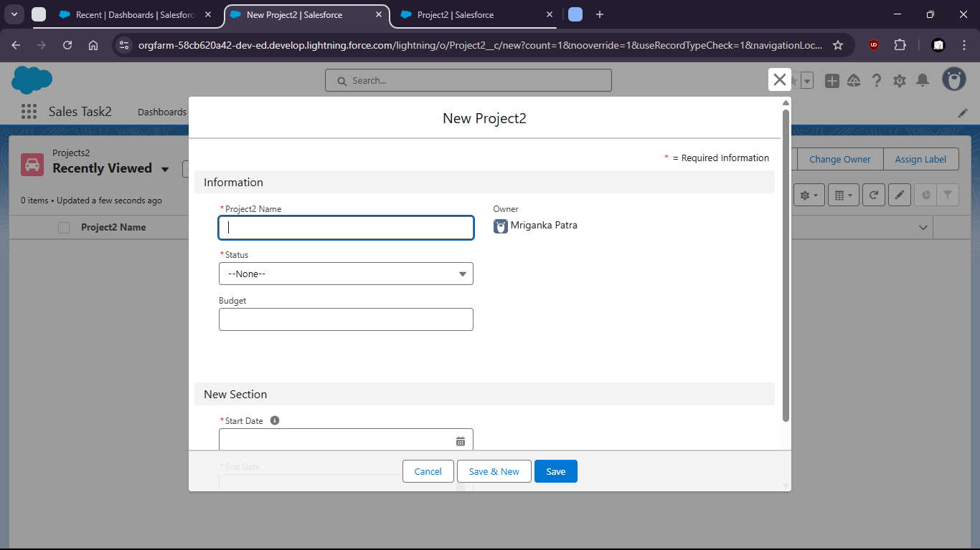

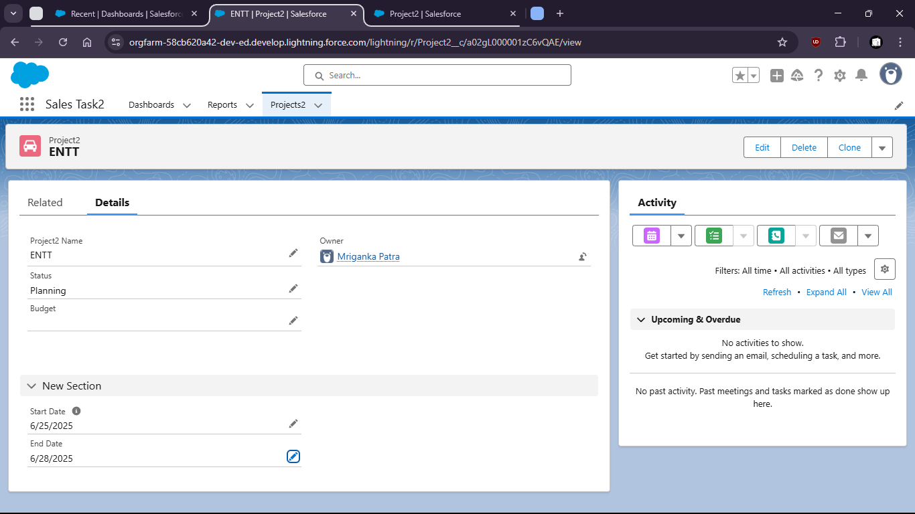

Task 6 : Use Lighting App Builder to create a new app including the ‘project” object and assign it to a profile

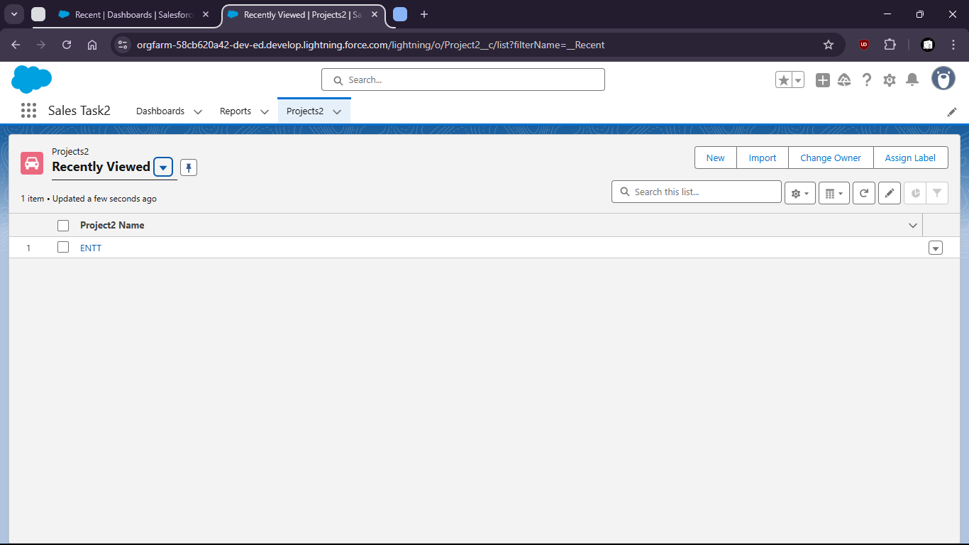

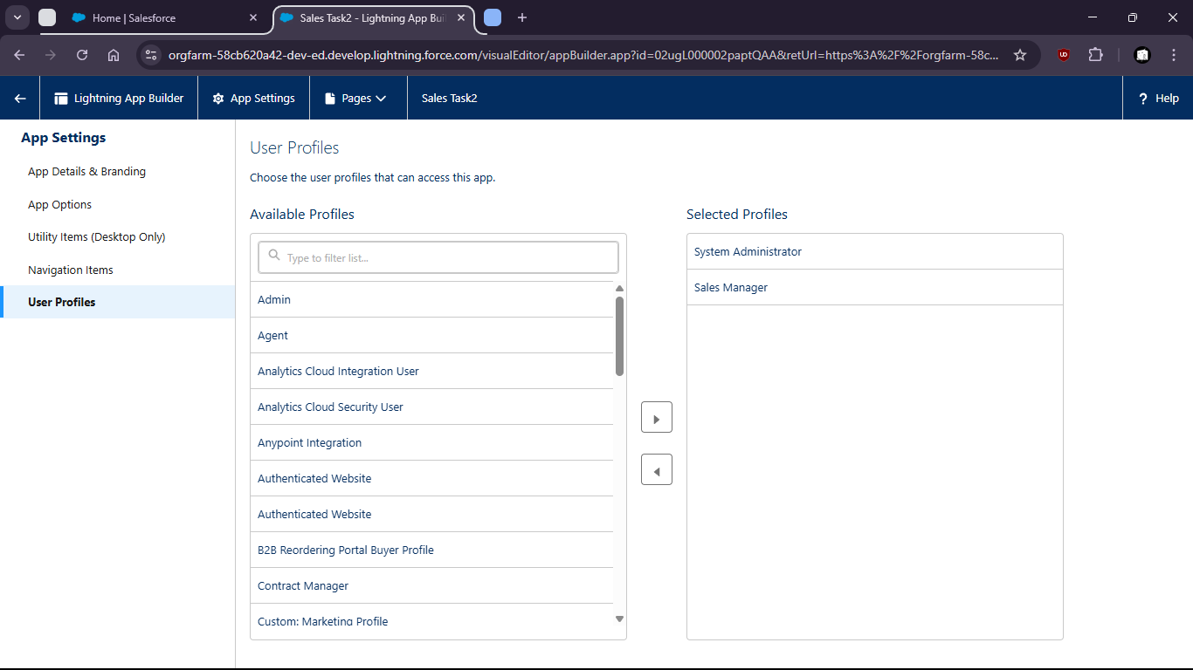

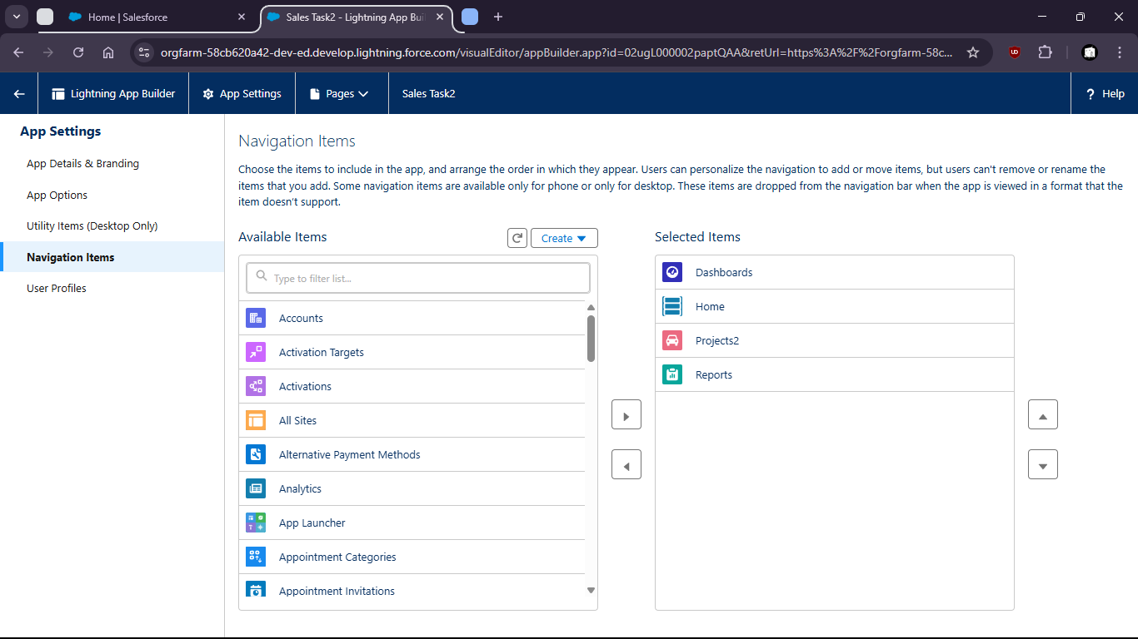

Task 7 : Create two different Record Types for ‘Project’: Internal and Client-based projects with different layouts

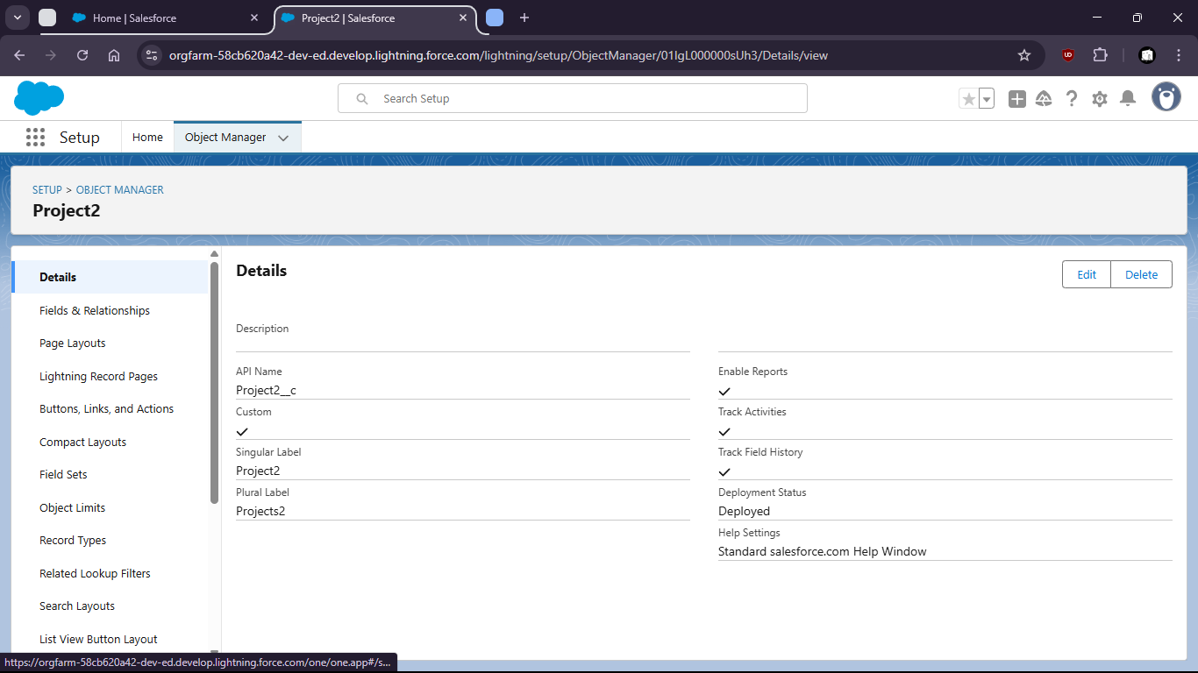

Inernal Project Layout (for Projects2)

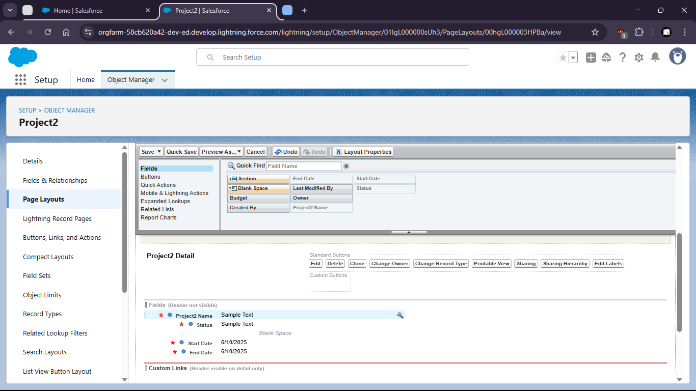

Client Project Layout

